CSE4107
Class Test 2, Spring 2019
Marks: 10 Time: 25 min.

106

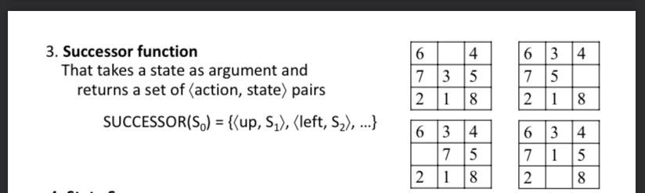
- Write a short note on ‘Successor function’. (2)

What are the main differences between A* search and Greedy Best-First search? (3)
Ans:
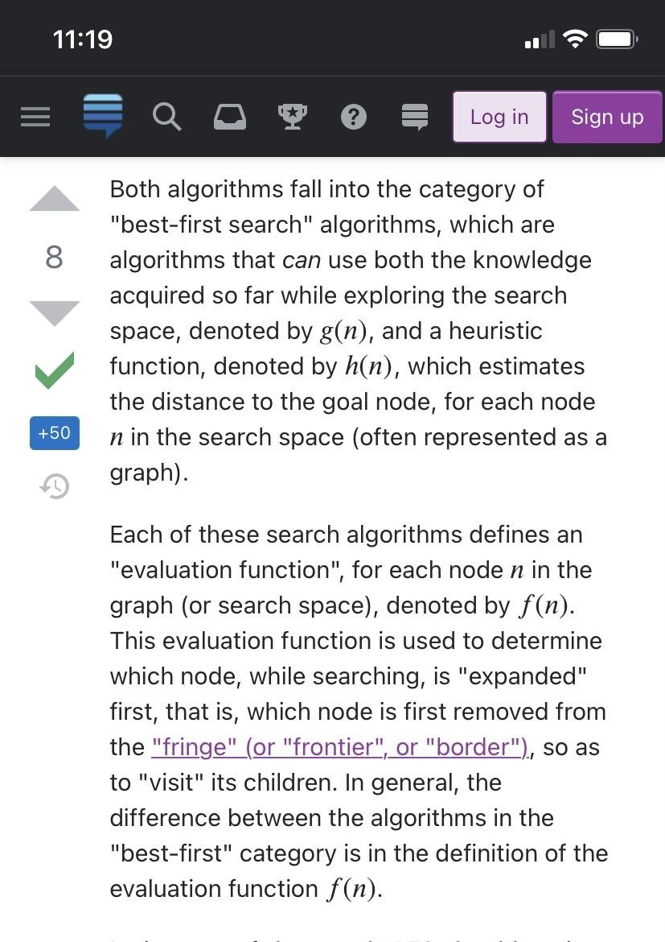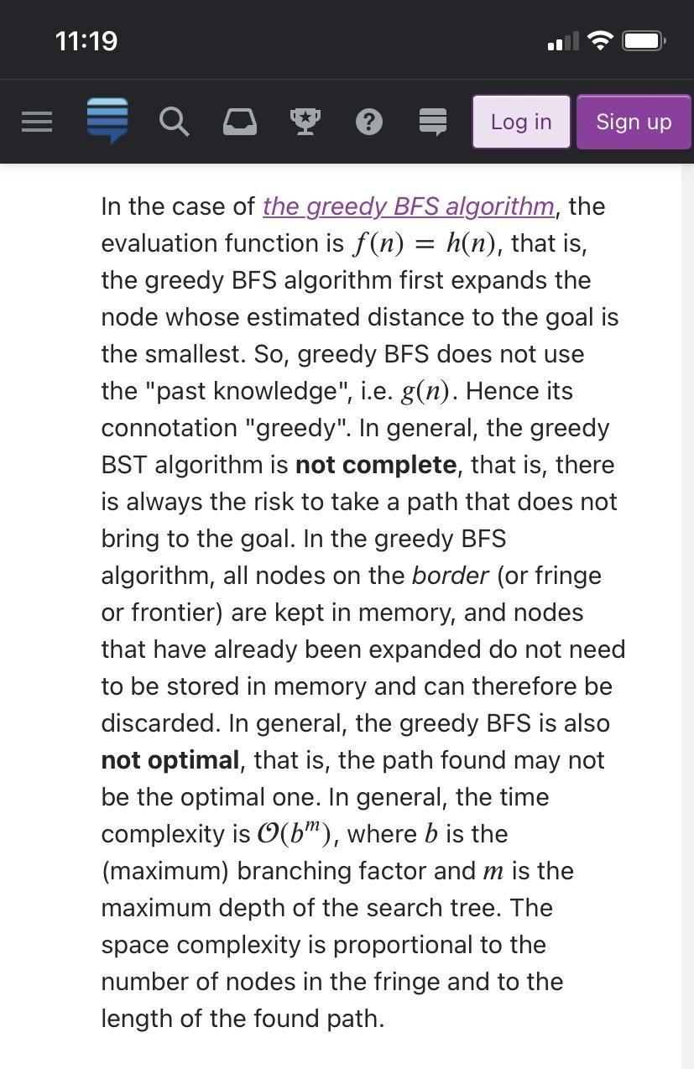

Explain the positive side of Hill-climbing local search. (2) Ans:
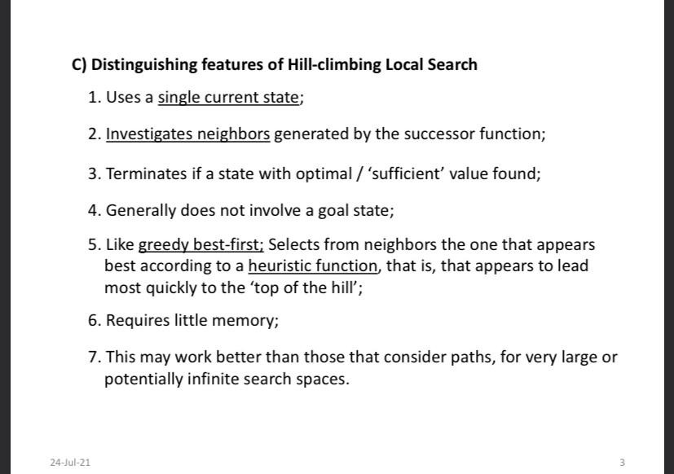
In each case, the algorithm reaches a point at which no progress is being made. Starting from a randomly generated 8-queens state, steepest-ascent hill climbing gets stuck 86% of the time, solving only 14% of problem instances. It works quickly, taking just 4 steps on average when it succeeds and 3 when it gets stuck—not bad for a state space with 88 ≈ 17 million states.

Elaborate the concept of New Population in connection with Genetic algorithms. (3)

Ans: For example, the first child of the first pair gets the first three digits from the first parent and the remaining digits from the second parent, whereas the second child gets the first three digits from the second parent and the rest from the first parent. The 8-queens states involved in this reproduction step are shown in Figure 4.7. The example shows that when two parent states are quite different, the crossover operation can produce a state that is a long way from either parent state. It is often the case that the population is quite diverse early on in the process, so crossover (like simulated annealing) frequently takes large steps in the state space early in the search process and smaller steps later on when most individuals are quite similar.

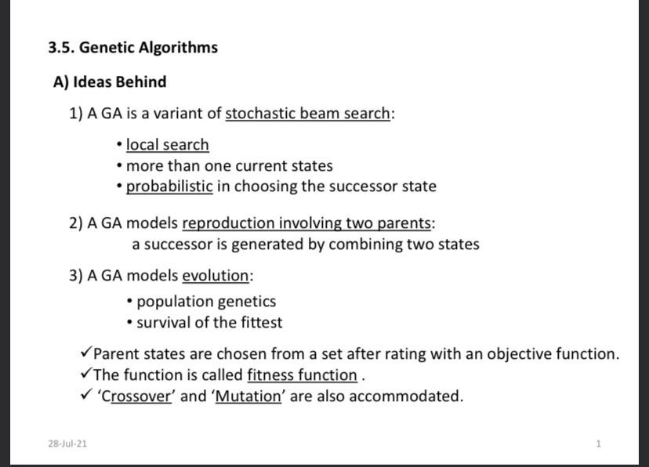

---------------------- 107

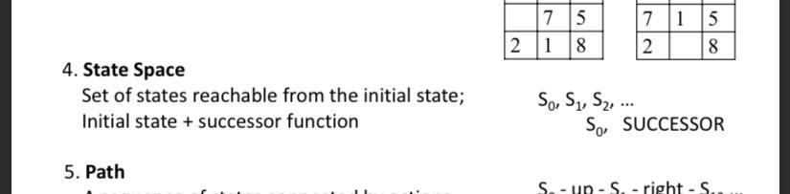
Write a short note on ‘State Space’. (2) Ans:

- Illustrate the concept of global maximum in connection with Hill-climbing local search. (3)

Ans:

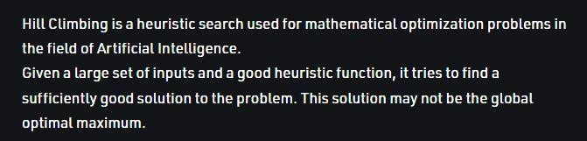

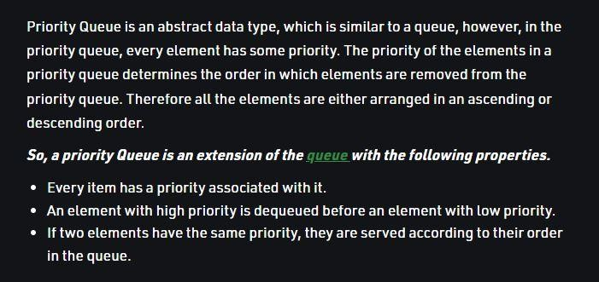
- What do you know about Priority Queues? (2) Ans:

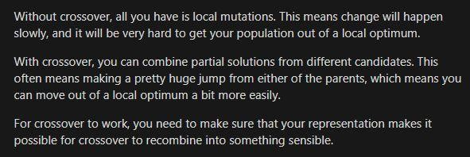
Explain the importance of Crossover used in Genetic algorithms. (3) Ans:

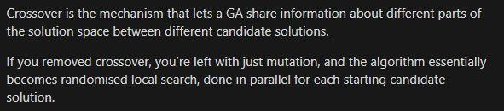

109

Explain the positive side of Greedy Best-First search. (3)
Ans: Greedy best-first search algorithm always selects the path which appears best at that moment. It is the combination of depth-first search and breadth-first search algorithms. It uses the heuristic function and search. Best-first search allows us to take the advantages of both algorithms. With the help of best-first search, at each step, we can choose the most promising node. In the best first search algorithm, we expand the node which is closest to the goal node and the closest cost is estimated by a heuristic function,f(n)=g(n). A priority queue is maintained that contains nodes in ascending order of h-values.

Justify the naming of the strategy called Hill-Climbing Local Search? (2)
Ans: The hill-climbing search algorithm is the most basic local search technique. Hill climbing algorithm continuously moves in the direction of increasing elevation/value to find the peak of the mountain or best solution to the problem. It terminates when it reaches a peak value where no neighbor has a higher value. Hill climbing is sometimes called greedy local search because it grabs a good neighbor state without thinking ahead about where to go next. Although greed is considered one of the seven deadly sins, it turns out that greedy algorithms often perform quite well. So,the naming strategy of hill climbing local search is justified.

How the parent generation is formed in Genetic algorithms? (2)
Ans: In genetic algorithms, parent generation is formed by taking better performing individuals from the fitness functions. Suppose we have 3 individuals rated using a fitness function where F(a)=23, F(b)=13, F(c)=22. Now, if 15 is the threshold value, parent generation is {a,c}. This is how parent generation is formed by a genetic algorithm.

Explain the positive side of Greedy Best-First search. (2) Ans:

  - Can switch between BFS and DFS, thus gaining the advantages of both.
  - More efficient when compared to DFS.
  - Node is expanded which is closest to the goal node and the closest cost is estimated by a heuristic function, f(n)=g(n).

110
- Illustrate the concept of consistency of heuristic functions with a concise example. (3)

Ans:
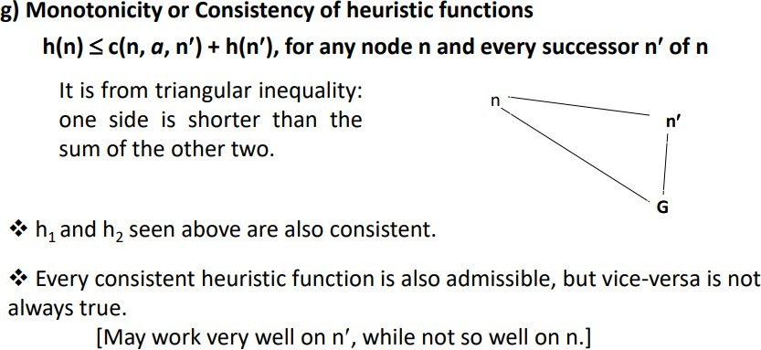
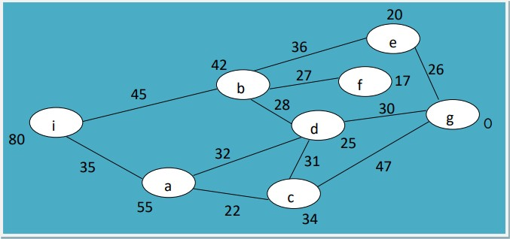

h(n) ≤ c(n, a, n`) + h(n`), for any node n and every successor n` of n h(i)=80 c(i, →, b) + h(b)=45+42, h(i)=80 c(i, →, a) + h(a)=35+55;

Why is a genetic algorithm called a stochastic beam search? (2)
Ans: Stochastic Beam Search (SBS) is a simple search procedure that starts with a set of initial solutions and explores their neighborhood solutions using successor functions. It then keeps track of only the most promising (in terms of fitness) k solutions.
A genetic algorithm (or GA) is a variant of stochastic beam search in which successor states are generated by combining two parent states rather than by modifying a single state. The analogy to natural selection is the same as in stochastic beam search, except that now we are dealing with sexual rather than asexual reproduction.

Explain the positive and negative sides of A* search. (3) Ans:

Positive:

  - It is an optimal search algorithm in terms of heuristics.
  - It is one of the best heuristic search techniques.
  - It is used to solve complex search problems.
  - There is no other optimal algorithm guaranteed to expand fewer nodes than A*.

Negative:

  - This algorithm is complete if the branching factor is finite and every action has fixed cost.
  - The performance of A* search is dependent on accuracy of the heuristic algorithm used to compute the function h(n).

Write a short note on First-choice Hill-climbing search. (2)
Ans: First-choice hill climbing implements stochastic hill climbing by generating successors randomly until one is generated that is better than the current state. This is a good strategy when a state has many (e.g., thousands) of successors.

111
- Write a short note on ‘Local search’. (2)

Ans: Local search algorithms operate using a single current node rather than multiple paths and generally move only to neighbors of that node. The paths followed by the search are not retained. Although local search algorithms are not systematic, they have two key advantages: (1) they use very little memory, usually a constant amount (2) they can often find reasonable solutions in large or infinite (continuous) state spaces for which

systematic algorithms are unsuitable. Local search algorithms are also useful for solving pure optimization problems, in which the aim is to find the best state according to an objective function.

Explain the major steps of A* search. (3)





- Write a brief essay on heuristic functions. (3)

Ans: The heuristic function is a way to inform the search about the direction to a goal. It provides an informed way to guess which neighbor of a node will lead to a goal.

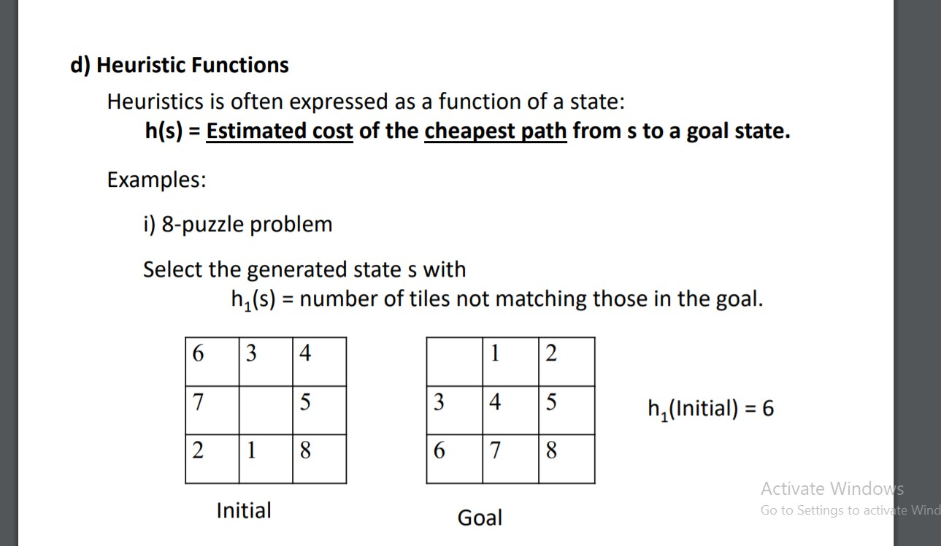
Finding a good heuristic function is a big problem. Statistical and probabilistic methods help in that aspect. And the good heuristic functions are said to be admissible and consistent.

How evolution is modeled in Genetic algorithms? (2)

Ans: Evolution is modeled in Genetic algorithms based on population genetics and survival of the fittest Here, parent states are chosen from a set after rating with an objective function, which is called fitness function. Also, ‘Crossover’ and ‘Mutation’ are accommodated here.

113
- Distinguish between blind and informed search. (2) Ans:
Informed Search
Blind Search

It doesn’t use knowledge for the searching process. |  |  | It uses knowledge for the searching process.
It finds solutions more quickly. |  |  | It finds solutions more quickly.
It is always complete. |  |  | It may or may not be complete.
Cost is high. |  |  | Cost is low.
It consumes moderate time. |  |  | It consumes less time.
No suggestion is given regarding the solution in it. |  |  | It provides the direction regarding the solution.
It is more implementation. | lengthy | while | It is less implementation. | lengthy | while
Depth First Search, Breadth First Search |  |  | Greedy Search, A* Search, Graph Search

Describe the major steps of a typical Hill-climbing local search algorithm. (3) Ans:
Typical Hill climbing is the simplest way to implement a hill climbing algorithm. It only evaluates the neighbor node state at a time and selects the first one which optimizes current cost and sets it as a current state. It only checks it's one successor state, and if it finds better than the current state, then move else be in the same state.
The major steps of a typical Hill -climbing local search algorithm -
- Evaluate the initial state, if it is a goal state then return success and Stop.
- Loop Until a solution is found or there is no new operator left to apply.
- Select and apply an operator to the current state.
- Check new state:
  - If it is a goal state, then return to success and quit.
  - Else if it is better than the current state then assign a new state as a current state.
  - Else if not better than the current state, then return to step2.
- Terminate/exit.

3. How reproduction is modeled in Genetic algorithms? (2) Ans:
The reproduction function determines how to expand the population based on the existing members. Reproduction is modeled in three steps in Genetic Algorithm. These are-
- Mutation: The simplest reproduction method is mutation, where each new member is based on a single individual
- Crossover: Crossover is a more complex method of reproduction, where each new

individual is based on some combination of existing individuals.
The reproduction function returns the new population, which may be the same size or a different size than the original population.

4. Illustrate the process of updating the Possible Path in Greedy Best-first search. (3) Ans:

115

How do you explain a Goal test in search problems? (2)
Ans: The goal test, which determines whether a given state is a goal state. Sometimes there is an explicit set of possible goal states, and the test simply checks whether the given state is one of them.Sometimes the goal is specified by an abstract property rather than an explicitly enumerated set of states. For example, in chess, the goal is to reach a state called “checkmate,” where the opponent’s king is under attack and can’t escape.

Explain three important decisions about A* search. (3) Ans:
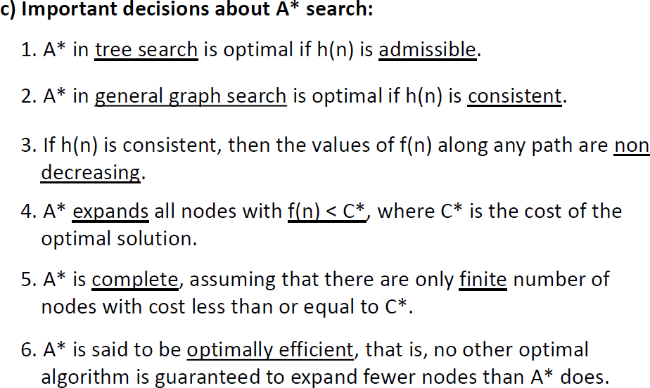

- Write a brief essay on ‘Some real problems require Hill-climbing local search’. (3)

Ans: The hill-climbing algorithm can be applied in the following areas:
Marketing: A hill-climbing algorithm can help a marketing manager to develop the best marketing plans. This algorithm is widely used in solving Traveling-Salesman problems. It can help by optimizing the distance covered and improving the travel time of sales team members. The algorithm helps establish the local minima efficiently.
Robotics:
Hill climbing is useful in the effective operation of robotics. It enhances the coordination of different systems and components in robots.
Job Scheduling:
The hill climbing algorithm has also been applied in job scheduling. This is a process in which system resources are allocated to different tasks within a computer system. Job scheduling is achieved through the migration of jobs from one node to a neighboring node. A hill-climbing technique helps establish the right migration route.

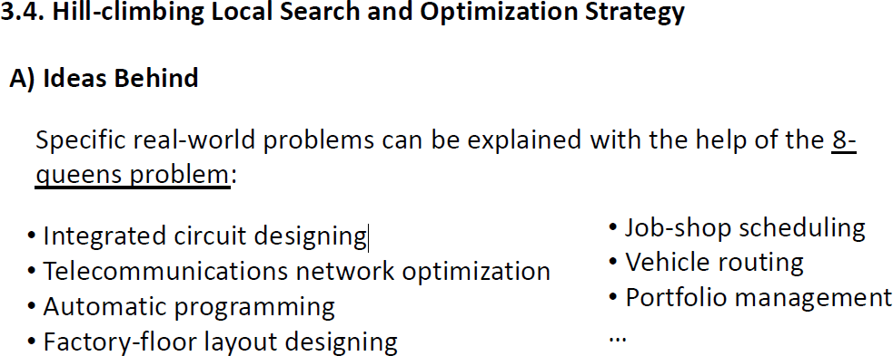

Elaborate the concept of Mutation in connection with Genetic algorithms. (2) Ans:
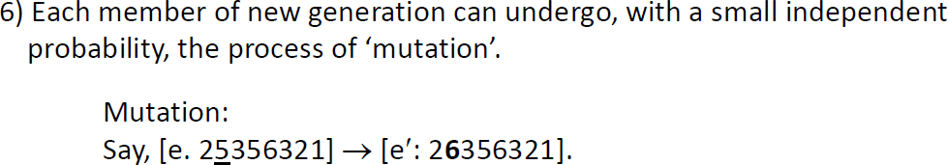

116

Write a short note on ‘Optimal solution of a search problem’. (2)

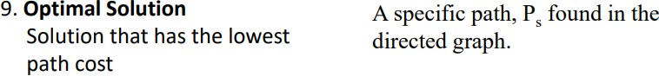

- Illustrate the odds of the environment of Hill-climbing local search problems. (3)
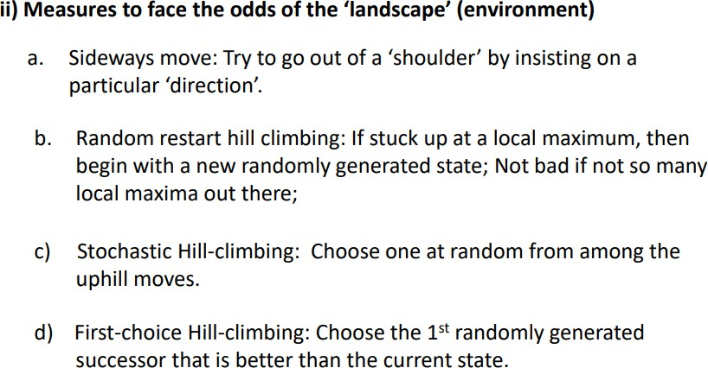

What do you know about the evaluation function of Greedy best-first search? (2)

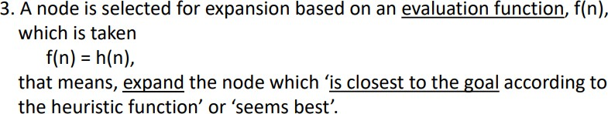

- Narrate the ideas that stand behind Genetic algorithms. (3)

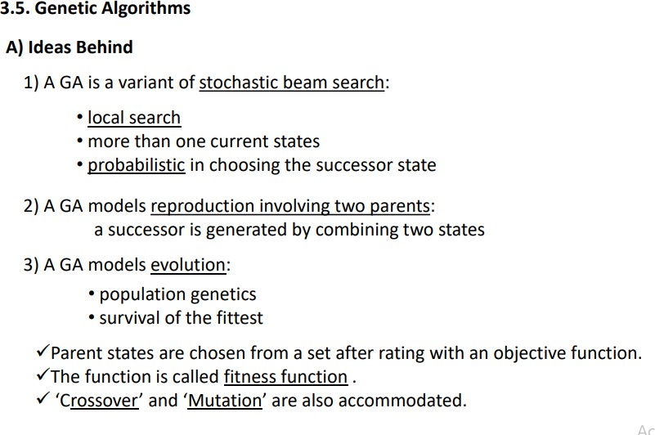

117
- Describe the conditions under which heuristic functions are considered good. (3)
Ans:

i) Admissibility of heuristic functions: An admissible heuristic function never over estimates the cost to reach the goal: h(s) <= Actual cost to reach the goal from s.
h1 and h2 seen above are admissible:
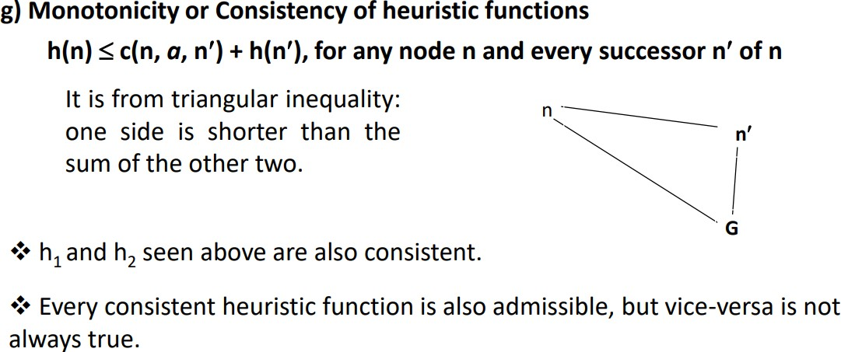
h1 – any tile that is out of place, must be moved at least once h2 – straight line is the shortest of any other lines

Explain three of the most important features of Hill-climbing Local Search. (3) Ans:
- Generate and Test variant: Hill Climbing is the variant of Generate and Test method. The Generate and Test method produce feedback which helps to decide which direction to move in the search space.
- Greedy approach: Hill-climbing algorithm search moves in the direction which optimizes the cost.. It is simply a loop that continually moves in the direction of increasing value—that is, uphill. I
- No backtracking: It does not backtrack the search space, as it does not remember the previous states.. Hill climbing does not look ahead beyond the immediate neighbors of the current state.

How the new generation is formed in Genetic algorithms? (2)
Ans: In genetic algorithms, parents are chosen randomly for ‘crossover’ and a new generation is obtained consisting of the ‘offsprings’. Suppose we have 4 individuals rated using a fitness function where F(a) =23, F(b)=13, F(c)=22.Now ,if 15 is the threshold value parent generation is {a,c,d}.Suppose a=25348716 d=31456321.Now if a and d are chosen for crossover and 4 is the crossover point then .253|48716 314|56321 new generation:e’=25356321 and f=31448716.This is how a new generation is formed in genetic algorithms.

Mark the negative points in Greedy Best-First search. (2) Ans:
  - The strategy is greedy,may not return a optimal solution
  - The strategy is not complete in the sense that it may unreasonably lead to great depth.

118
- Explain the necessity of heuristic functions for problem solving. (2) Ans:



Narrate those major steps of a typical genetic algorithm that are repeatedly executed. (3)

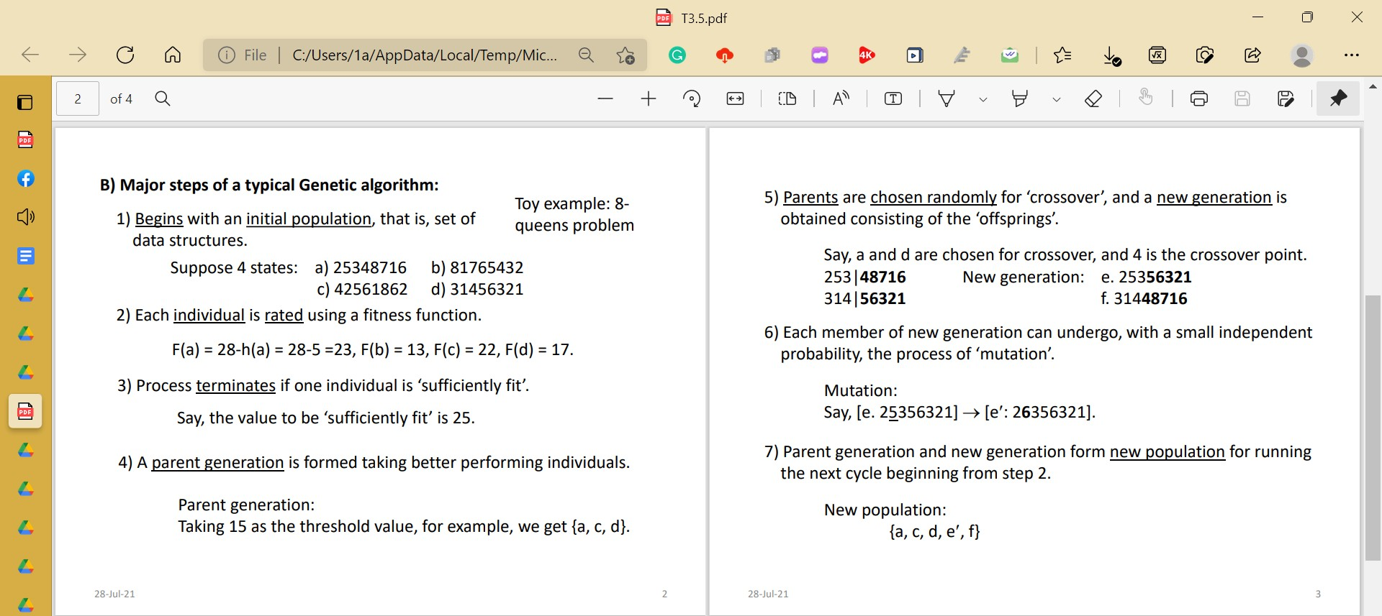
Ans:

What are the problems with A* search, and how those can be addressed? (3) Ans:




- Write a short note on Random restart Hill-climbing search. (2) Ans:

120

- Write a short note on ‘Local maximum’. (2)

Local maximum: It is a state which is better than its neighboring state however there exists a state which is better than it(global maximum). This state is better because here the value of the objective function is higher than its neighbors.

Narrate the major steps of A* search that is repeatedly executed. (3)

The most widely known form of best-first search is called A∗ search. It evaluates nodes by combining g(n), the cost to reach the node, and h(n), the cost to get from the node to the goal: f(n) = g(n) + h(n). Since g(n) gives the path cost from the start node to node n, and h(n) is the estimated cost of the cheapest path from n to the goal, we have f(n) = estimated cost of the cheapest solution through n.
Thus, if we are trying to find the cheapest solution, a reasonable thing to try first is the node with the lowest value of g(n) + h(n). It turns out that this strategy is more than just reasonable: provided that the heuristic function h(n) satisfies certain conditions, A∗ search is both complete and optimal. The algorithm is identical to UNIFORM-COST-SEARCH except that A∗ uses g + h instead of g.

Write a brief essay on Consistency of heuristic functions. (3)

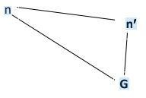
h(n) c(n, a, n) + h(n), for any node n and every successor n of n

It is from triangular inequality:
one side is shorter than the sum of the other two.

- h1 and h2 are consistent.

Where, h1 – any tile that is out of place, must be moved at least once

h2 – straight line is the shortest of any other lines

- Every consistent heuristic function is also admissible, but vice-versa is not always true.

[May work very well on n, while not so well on n.]

How Crossover is executed in Genetic algorithms? (2)

1) A Genetic Algorithm is a variant of stochastic beam search.

One of the major steps of a typical Genetic algorithm is “Crossover” where parents are chosen randomly for the crossover and the new generation is obtained consisting of the “offspring”.

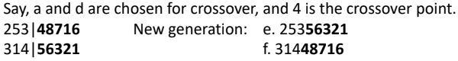

121

- Write a short note on ‘Admissibility of heuristic functions’. (2)

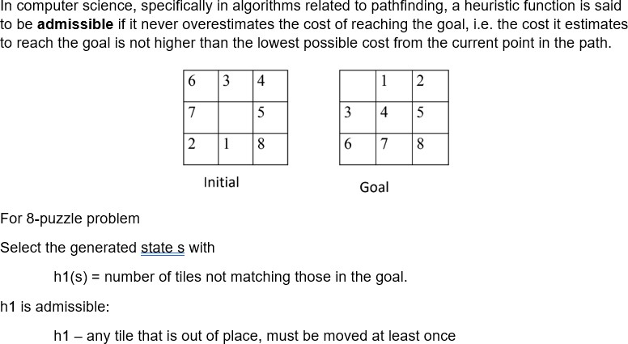

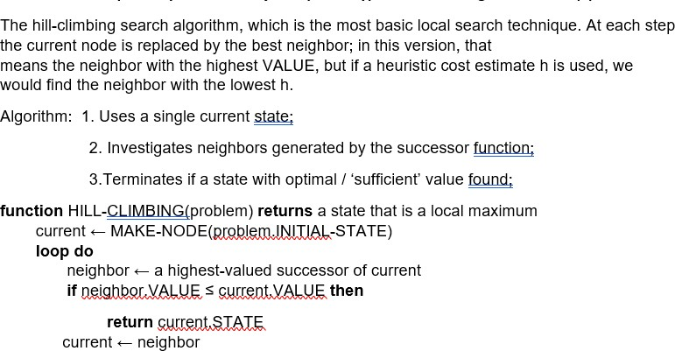
Describe the repeatedly executed major steps of a typical Hill-climbing local search. (3)
- How randomness is applied in Genetic algorithms? (2)

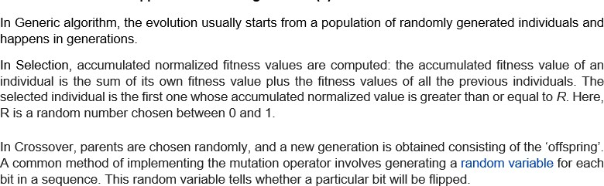

Explain the positive and negative sides of Greedy Best-first search. (3)
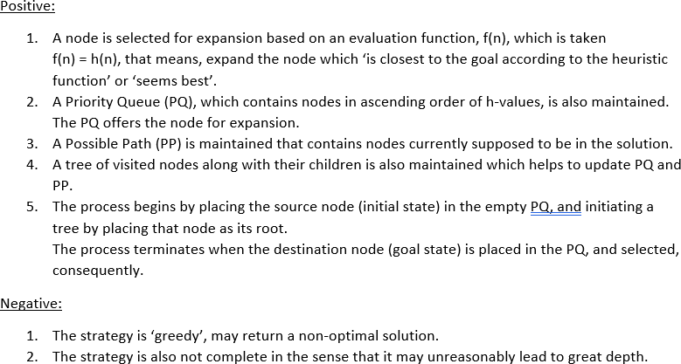

122

Write a short note on ‘Solution to AI problems’. (2) Ans:

- Why and how a tree of nodes is maintained in Greedy Best-first search? (3)

Ans: A tree of visited nodes along with their children is maintained in Greedy Best-first search which helps to update the Priority Queue (PQ) and the Possible Path (PP). The Priority Queue contains nodes in ascending order of h-values. The PQ offers the node for expansion. The Possible Path (PP) contains nodes currently supposed to be in the

solution.

How a tree of nodes is maintained:

  - The process begins by placing the source node (initial state) in the empty PQ, and initiating a tree by placing that node as its root.
  - The process terminates when the destination node (goal state) is placed in the PQ, and selected, consequently.
  - The 1st node from the PQ is selected repeatedly, and each time the tree, the PQ and the PP are updated:
    - The node in the tree is marked visited and its neighbors from the graph are added to the tree as its children, while no repeated node is allowed in the tree;
    - The node itself is deleted from the PQ, but its children added to the tree are also added to the PQ.
    - The PP is straightened up to the root from the selected node.

For what type of problems Hill-climbing local search is appropriate? (2)

Ans: Hill Climbing local search is appropriate for mathematical optimization problems in the field of Artificial Intelligence. Mathematical optimization problems imply that hill-climbing solves the problems where we need to maximize or minimize a given real function by choosing values from the given inputs. Hill Climbing technique can be used to solve many problems, where the current state allows for an accurate evaluation function, such as Network-Flow, Traveling Salesman problem, 8-Queens problem, Integrated Circuit design, etc.
Given a large set of inputs and a good heuristic function, it tries to find a sufficiently good solution to the problem. This solution may not be the global optimal maximum.

Elaborate the concept of Population in connection with Genetic algorithms. (3)

Ans: Genetic Algorithms begin with a set of randomly generated states, called the population. Each state, or individual, is represented as a string over a finite alphabet—most commonly, a string of 0s and 1s.The population has a fixed size. As new generations are formed, individuals with least fitness die, providing space for new offspring. The sequence of phases is repeated to produce individuals in each new generation which are better than the previous generation.
The production of the next generation of states is rated by the objective function, or (in GA terminology) the fitness function. A fitness function should return higher values for better states. A parent generation is formed taking better performing individuals. Parents

are chosen randomly for ‘crossover’, and a new generation is obtained consisting of the ‘offsprings’. Each member of the new generation can undergo, with a small independent probability, the process of ‘mutation’. Parent generation and new generation form a new population for running the next cycle.

125
- Write a short note on ‘Path cost of AI problems’. (2)

Ans: Path-finding is the task of finding the shortest path between two given nodes in a graph, and has been studied in computer science (CS) for almost forty years. Theoretical advances are still being made and real-world applications abound. For example, there are commercial products that find routes optimizing the cost or time to drive between two locations in a city or country. Path-finding arises as a subtask in many areas of artificial intelligence (AI). For example, in natural language understanding, lexical disambiguation has been partially solved by finding paths between word senses in a knowledge base. A path cost function assigns a numeric cost to each path. One that has the lowest path cost among the solutions gives the desired resulting condition in a given problem, and what search algorithms are looking for.

Illustrate the concept of local maxima in connection with Hill-climbing local search.
(3)

Ans: A local maximum is a peak that is higher than each of its neighboring states but lower than the global maximum. Hill-climbing algorithms that reach the vicinity of a local maximum will be drawn upward toward the peak but will then be stuck with nowhere else to go. Figure 4.1 illustrates the problem schematically.
To illustrate hill climbing, we will use the 8-queens problem .Local search algorithms typically use a complete-state formulation, where each state has 8 queens on the board, one per column. The successors of a state are all possible states generated by moving a single queen to another square in the same column (so each state has 8 × 7 = 56 successors). The heuristic cost function h is the number of pairs of queens that are attacking each other, either directly or indirectly. The global minimum of this function is zero, which occurs only at perfect solutions.
In each case, the algorithm reaches a point at which no progress is being made. Starting from a randomly generated 8-queens state, steepest-ascent hill climbing gets stuck 86% of the time, solving only 14% of problem instances. It works quickly, taking just 4 steps on average when it succeeds and 3 when it gets stuck - not bad for a state space with 88 ≈ 17 million states.
The success of hill climbing depends very much on the shape of the state-space

landscape: if there are few local maxima and plateaus, random-restart hill climbing will find a good solution very quickly.

What do you know about the evaluation function of A* search? (2)

Ans: A* algorithm is a form of heuristic search that tries to find the cheapest path from the initial state to the goal. Its characteristic feature is the evaluation function. This is the sum of two components: the estimated minimum cost of a path from the initial state to the current state, and the estimated cost from the current state to the goal. The first component can be calculated if the search space is a tree, or it can be approximated by the cheapest known path if the search space is a graph. The second component must be defined, like any evaluation function, with respect to the domain. The heuristic power of this method depends on the properties of the evaluation function.
It evaluates nodes by combining g(n), the cost to reach the node, and h(n.), the cost to get from the node to the goal: f(n) = g(n) + h(n). Since g(n) gives the path cost from the start node to node n, and h(n) is the estimated cost of the cheapest path from n to the goal.

Narrate the importance of Crossover and Mutation used in Genetic algorithms. (3)

Ans: A genetic algorithm is a stochastic hill-climbing search in which a large population of states are maintained. New states are generated by mutation and by crossover, which combines pairs of states from the population.
Crossover and mutation perform two different roles. Crossover (like selection) is a convergence operation which is intended to pull the population towards a local minimum/maximum. In an interesting aside, crossover is not one of the original genetic operators; Holland's original thesis used only selection and probabilistic mutation.
Mutation is a divergence operation. It is intended to occasionally break one or more members of a population out of a local minimum/maximum space and potentially discover a better minimum/maximum space.
Since the end goal is to bring the population to convergence, selection/crossover happen more frequently (typically every generation). Mutation, being a divergence operation, should happen less frequently, and typically only affects a few members of a population (if any) in any given generation.

148

- Illustrate the conditions under which heuristic functions are considered good. (3)
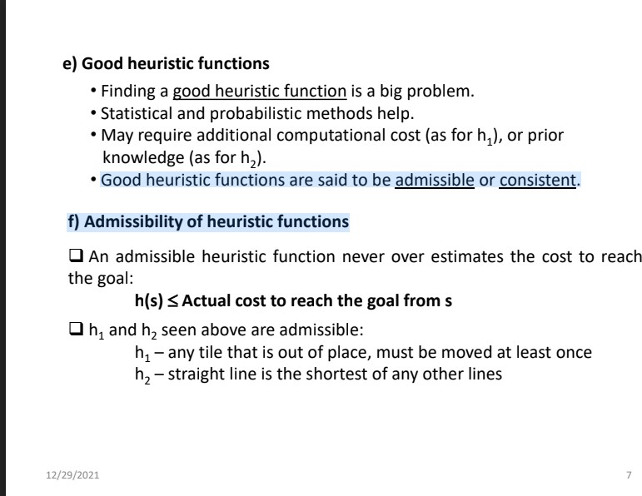
Ans:

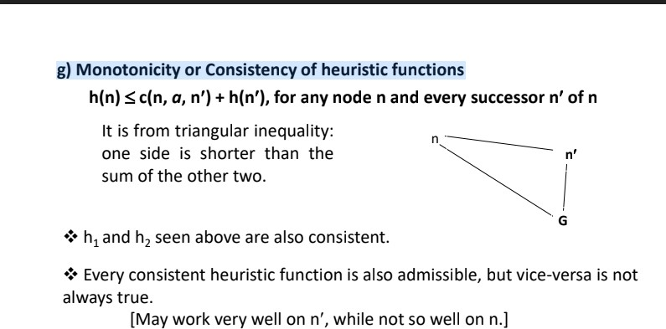

Justify the naming of the strategy called Hill-climbing Local Search. (3)
Ans: Hill climbing algorithm is a local search algorithm which continuously moves in the direction of increasing elevation/value to find the peak of the mountain or best solution to the problem. It terminates when it reaches a peak value where no neighbor has a higher value.It is also called greedy local search as it only looks to its good immediate neighbor state and not beyond that. It is an iterative algorithm that starts with an arbitrary solution to a problem, then attempts to find a better solution by making an incremental change to the solution.

How the new generation is formed in Genetic algorithms? (2) Ans:

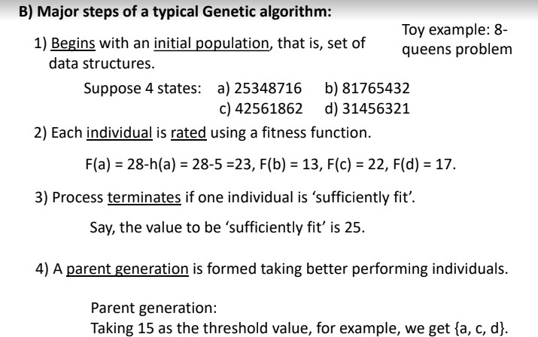

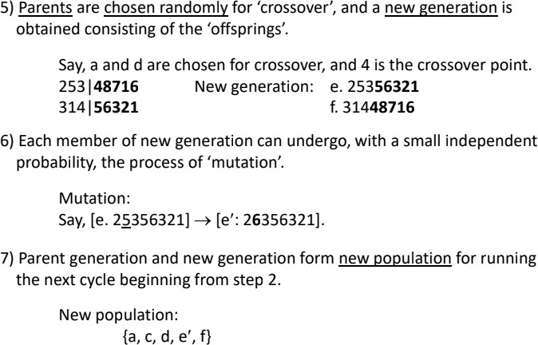

- Explain the negative side of A* search. (2) Ans:
- Number of expanded nodes for most problems grows exponentially.

- Admissible and consistent heuristics are very hard to find.

151
- Illustrate the concept of consistency of heuristic functions with a concise example. (3)
Ans: 110 has filled it already. <3

Why is a genetic algorithm called a local search? (2)
Ans: Genetic Algorithms have been seen as search procedures that can quickly locate high performance regions of vast and complex search spaces, but they are not well suited for fine-tuning solutions, which are very close to optimal ones. However, genetic algorithms may be specifically designed to provide an effective local search as well. In fact, several genetic algorithm models have recently been presented with this aim.genetic al- gorithms may be specifically designed to provide an effective local search as well.

- Explain the positive and negative sides of Greedy Best-first search. (3) Ans: 121 has filled it already. <3

Write a short note on ‘Stochastic Hill-climbing search’. (2)
Ans: Stochastic hill climbing is a variant of the basic hill climbing method. While basic hill climbing always chooses the steepest uphill move, "stochastic hill climbing chooses at random from among the uphill moves; the probability of selection can vary with the steepness of the uphill move.
It is also a local search algorithm, meaning that it modifies a single solution and searches the relatively local area of the search space until the local optima is located. This means that it is appropriate on unimodal optimization problems or for use after the application of a global optimization algorithm.

101

- Write a short note on ‘Hill-climbing search’. (2)
Ans: Hill climbing algorithm is a local search algorithm which continuously moves in the direction of increasing elevation/value to find the peak of the mountain or best solution to the problem. It terminates when it reaches a peak value where no neighbor has a higher value.A node of hill climbing algorithm has two components which are state and value.In this algorithm, we don't need to maintain and handle the search tree or graph as it only keeps a single current state.

Features of Hill Climbing: 1.Generate and Test variant

- Greedy approach 3.No backtracking

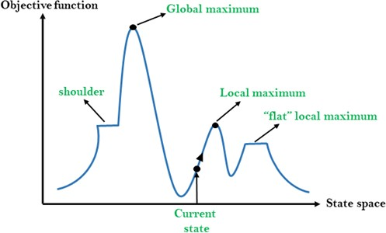

X-axis: denotes the state space i.e. states or configuration our algorithm may reach. Y-axis: denotes the values of objective function corresponding to a particular state.

- Narrate the major steps of A* search that is repeatedly executed. (3) Ans: See ID-120’s 2nd ans.

Illustrate the concept of heuristic functions. (3)
Ans: A heuristic function (algorithm) or simply a heuristic is a shortcut to solving a problem when there are no exact solutions for it or the time to obtain the solution is too long. The goal of the function is to find a faster solution or an approximate one, even if it is not optimal. In other words, when using a heuristic, we trade accuracy for the speed of the solution.
For example, greedy algorithms usually produce quick but suboptimal solutions. A greedy algorithm to find the largest sum in the following tree would go for the red path while the optimal path is the green one:

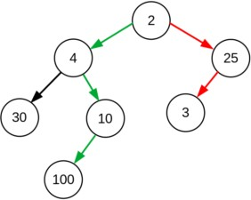

Heuristics don’t always lead to a lower cost. However, those that don’t overestimate the true or the lowest possible cost of a solution are called admissible heuristics.

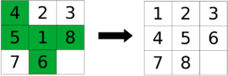
Here we start from the state on the left, and we want to reach the goal state on the right. As a heuristic solution to this puzzle, we can think of the Hamming distance between the two states, which is the number of misplaced tiles highlighted in green. Here, we have relaxed the constraints of the problem by assuming that we can just pick up a tile and put it in its right place.

There are numerous problems for which we can come up with a heuristic algorithm to solve.Few of them are :
- A* Search
- Traveling Salesman Problem (TSP)
- Distance on Grid Maps

How Crossover is executed in Genetic algorithms? (2)
Ans: Create two random crossover points in the parent and copy the segment between them from the first parent to the first offspring. Now, starting from the second crossover point in the second parent, copy the remaining unused numbers from the second parent to the first child, wrapping around the list.

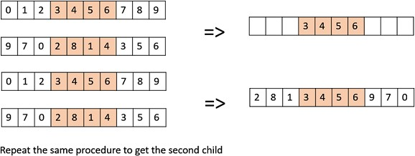

129
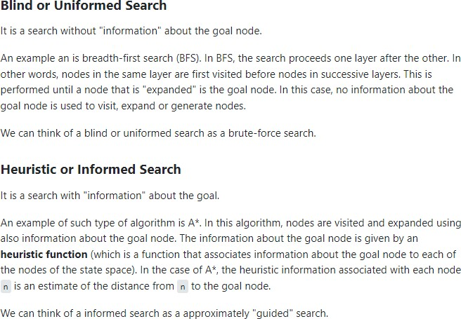
- Distinguish between blind and informed search. (2)

Ans:

- Describe the repeatedly executed major steps of a typical Genetic algorithm. (3)

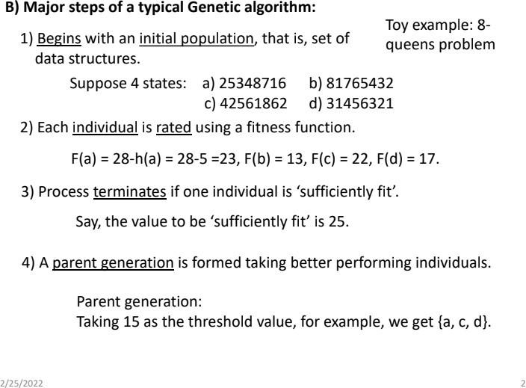
Ans:

- Explain the positive side of Hill-climbing local search. (2) Ans: See ID-106’s 3rd ans.

Illustrate the process of updating the Possible Path in A* search. (3) Ans: do it yourself

